ARC-AGI-2
Qwen3.8-27B Experiment Master Plan
Standalone Qwen Architecture -> Controlled Experiments -> NVARC Integration
Target runtime: 4 x NVIDIA L4 | Offline Kaggle | Qwen3.8-27B-FP8 TP=4 | Existing Qwen3-4B NVARC baseline
Master rule: Do not merge every promising solver idea at once. Run one mechanism at a time, keep only mechanisms that add reproducible unique coverage or efficiency, and integrate with NVARC only after the Qwen branch earns promotion.

English master reference | Priority-ordered | Source-audited
Prepared from the source-verified 12-solver audit, the Qwen3.8 EXP-1 notebook, the EXP0/EDA findings, and the 32.64-LB NVARC notebook/diagnostics.

Executive Decision
Current objective: Build a strong, measurable Qwen3.8-27B generator first. Only then combine it with the existing NVARC Qwen3-4B specialist. The goal is complementary candidate coverage, not replacing NVARC.

- Keep one resident Qwen3.8-27B-FP8 TP=4 engine on the four L4 GPUs. Logical roles are sequential/batched; do not load multiple 27B copies.
- Use the existing EXP-1 direct OFF/XHIGH notebook as the frozen baseline and runtime harness.
- The first causal comparison is PiVOTools-style stateful REPL versus Poetiq-style fresh-call deterministic code repair under matched token/time budgets.
- Do not add a holistic judge until candidate/oracle coverage is clearly higher than selected pass@2. Ranking cannot recover a correct grid that was never generated.
- For NVARC integration, preserve the current NVARC path and leaderboard behavior first. Add Qwen as a separate generator, then test low-risk union strategies before changing attempt_1.
- Route later Qwen compute using label-free task features and NVARC uncertainty/diversity. Never use ground-truth-derived near-miss signals for hidden/private inference.

One-page experiment order
Order | Experiment | Run only when | Decision after run
0 | LOAD-Q27 | Always first | Runtime stable -> freeze engine
1 | DIR-Q27 | After load proof | Freeze OFF/XHIGH + parser/serialization baseline
2 | PIV-Q27-P0 | After direct baseline | Keep only if it adds verified coverage or strong efficiency
3 | PTQ-Q27-T0 | Paired with PIV | Choose PIV, PTQ, or their union under matched budget
4 | LANG-Q27-L0 | Only if agentic code adds value | Keep only if it adds different mechanics / unique solves
5 | CORE-Q27-C0 | Only on object-heavy / collapse cases | Conditional specialist, not global branch
6 | LIB-Q27-E0 | Only after code branch works | Keep if retrieval cuts iterations or adds coverage without negative transfer
7 | JUD-Q27-J0 | Only after oracle-selected gap appears | Use judge only if selection, not generation, is the bottleneck
8+ | Athanor / Squeeze / Imbue / ARCgentica | Only after earlier ladder is measured | One-by-one late ablations; never merge them simultaneously
Integration | NVARC-B0 -> B4 | After Qwen generator promotion | Preserve NVARC attempt_1 first; then increase integration depth

1. Fixed System Constraints and Evaluation Protocol

1.1 Qwen runtime that must remain stable
- Checkpoint: qwen3-8-27b-fp8-repacked-v1, model_type=qwen3_5, FP8 E4M3 dynamic quantization.
- vLLM 0.19.0, tensor_parallel_size=4, distributed_executor_backend="mp", language_model_only=True.
- max_num_batched_tokens=32768, max_num_seqs=16, gpu_memory_utilization=0.90, enforce_eager=True, disable_custom_all_reduce=True, prefix caching disabled in the current baseline.
- Context policy: current notebook derives max_model_len from prompt length and requested generation, bounded between 18,432 and 32,768.
- Reasoning modes already validated by tokenizer/template: enable_thinking=False and enable_thinking=True with reasoning_effort="xhigh".
- Kaggle wall-clock budget: 12 hours with the current notebook reserving 30 minutes. New branches must preserve a similar safety reserve.

1.2 Frozen evaluation progression
- Smoke-16: runtime, parsing, tool/sandbox and checkpoint correctness only. Do not use this set to choose a final algorithm.
- Proxy-48 / frozen hard-proxy set: fast causal ablations with the same task IDs, seeds, time budget and logging schema across variants.
- Full 120 Public Evaluation: only for promoted variants. Report both current Kaggle output-weighted pass@2 and task-normalized/full-task metrics.
- EXP0 propensity weighting remains diagnostic only; it is not the official score and must not replace raw metrics.
- For every Qwen variant, compute NVARC union/oracle statistics offline on the same evaluation outputs before touching the submission integration.

1.3 Mandatory metrics
Metric | Why it matters | Use for promotion?
Output-weighted pass@2 | Official 2026 Kaggle denominator | Yes
Task-normalized / full-task score | Historical comparability and multi-query diagnostics | Secondary
GT/oracle in candidate pool | Separates generation failure from selection failure | Yes
Unique additions over NVARC | Primary evidence of complementarity | Yes
Valid-grid rate / parse failures | Measures interface robustness | Yes
All-train-exact program rate | Measures executable hypothesis quality | Yes for code branches
Duplicate ratio / unique candidates | Detects search collapse | Yes
Tokens and wall-clock per test output | Determines 4xL4 feasibility | Yes
EDA segments | Dynamic, multi-query, large/high-ratio, rare-color, hard tiers | Yes
Seed stability | Avoids keeping lucky stochastic branches | Yes on promoted variants
Promotion rule: A mechanism moves forward only if it adds reproducible unique candidate coverage, improves the official/secondary metric, or produces a clear compute-efficiency win. If it only reproduces the same grids at higher cost, drop it.

2. Architecture A - Standalone Qwen3.8-27B Research System
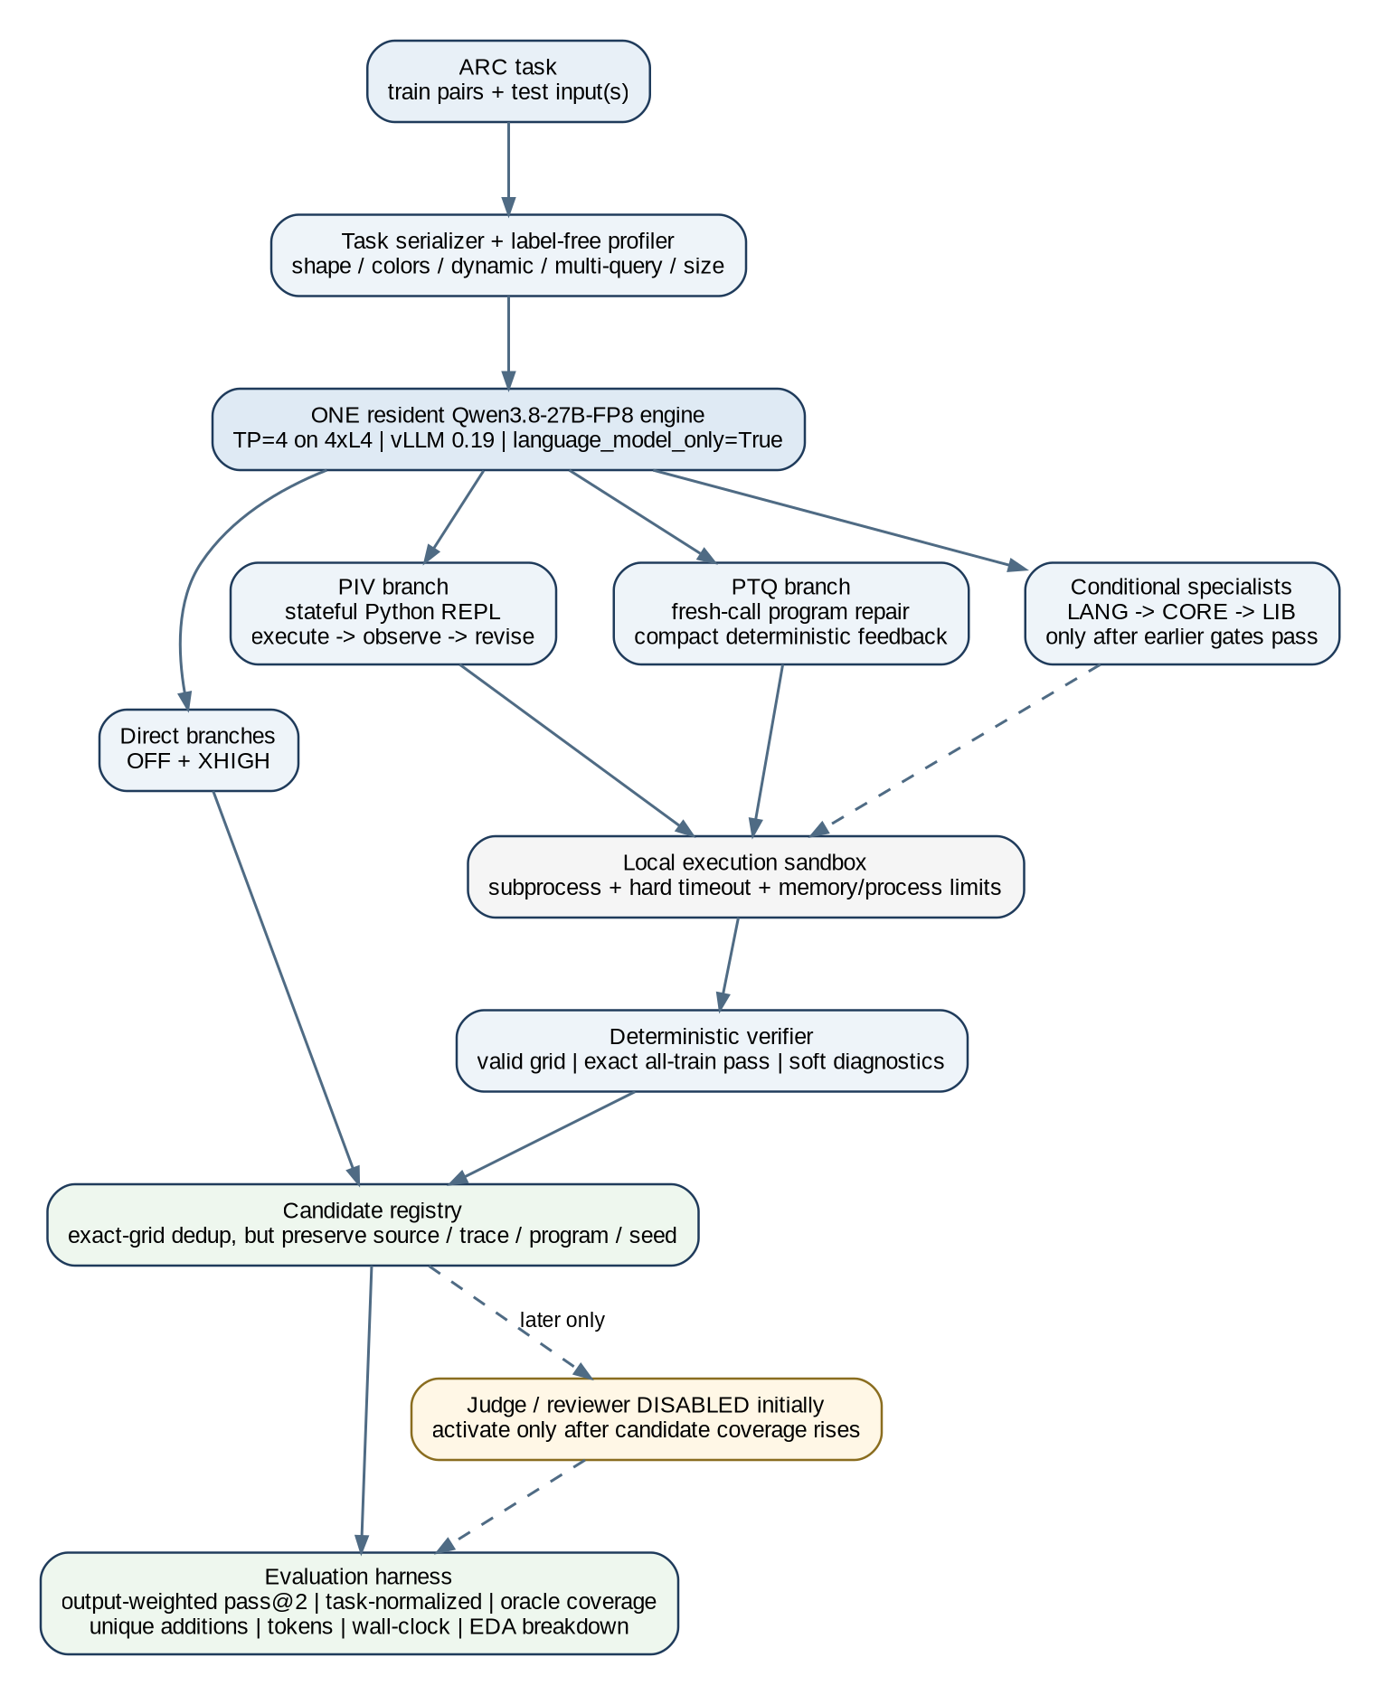

2.1 Architecture principles
- Single-model residency: one TP4 Qwen engine stays loaded. Direct, agent, verifier-review and judge roles are logical stages, not separate GPU-resident models.
- Candidate-first design: every branch writes a structured candidate record immediately. The experiment harness should survive branch failure without losing completed work.
- Execution is authoritative for code branches: final grids come from local program execution, never from prose transcription.
- Exact-grid deduplication does not discard provenance. If NVARC, PIV and PTQ all produce the same grid, keep one grid plus all source/trace/program metadata.
- Judging stays off during early generation experiments. First increase the probability that the correct grid exists in the pool.

2.2 Minimal candidate record
Field | Required | Purpose
task_id / test_index | Yes | Unambiguous output-level scoring
source / branch / seed | Yes | Provenance and independent-family diversity
grid | Yes | Canonical candidate output
valid_grid / shape | Yes | Parser and structural gate
train_exact / train_soft | For programs | Deterministic evidence
hypothesis_summary | Recommended | Compact mechanic trace
program_text / program_hash | For programs | Reproducibility and dedup
tokens / wall_time / tool_calls | Yes | Compute accounting
parent_ids | For refinement/evolution | Lineage tracking
raw_trace_path | Yes for promoted branches | Later holistic judging without bloating live context

3. Priority-Ordered Qwen3.8-27B Experiments
How to use this section: Run the next experiment only after the previous gate is recorded. Do not implement the entire roadmap in one notebook revision.

Q0 / LOAD-Q27 - TP4 load and warmup proof
Priority | Mandatory - first
Purpose | Prove that the exact repacked Qwen3.8-27B-FP8 checkpoint reliably initializes and generates on all four L4 GPUs before any ARC algorithm work.
Minimal implementation | Use the existing SMOKE_GPU path exactly: 4 visible GPUs, vLLM 0.19.0, TP=4, one short OFF generation. Require explicit MODEL LOAD COMPLETE and REAL MODEL WARMUP: PASS markers. Add only minimal TP/NCCL diagnostics if the run stalls.
Run order | SMOKE_GPU only; no full evaluation.
Metrics to log | GPU visibility/memory, load time, warmup time, max_model_len, vLLM/Torch/CUDA versions, first-generation success.
Promotion gate | Three clean runs or one clean Kaggle rerun with stable load/warmup and no engine deadlock.
Stop / rollback rule | Do not proceed to ARC scoring if runtime load is not proven. Fix process/NCCL/vLLM startup first.
Local adaptation | This is our runtime gate, not a solver-paper experiment.

Q1 / DIR-Q27 - Direct OFF vs XHIGH + interface freeze
Priority | Mandatory - second
Purpose | Measure raw Qwen reasoning capability and freeze the parser/serialization interface before adding tools.
Minimal implementation | Run matched direct branches with thinking OFF and XHIGH. Keep candidate outputs separate. Include one controlled formatting ablation only: current strict structured output versus a minimal/tolerant format (CSV or plain grid parser) if parse failure is non-trivial. Do not add agents yet.
Run order | Smoke-16 -> Proxy-48 -> Full-120 only if runtime is stable.
Metrics to log | OFF/XHIGH exact score, union score, valid-grid rate, output length, tokens, latency, EDA segments, NVARC offline union/oracle.
Promotion gate | Freeze the best interface by parse reliability + exact/union coverage, not by prompt aesthetics. Keep both OFF and XHIGH only if they add complementary grids.
Stop / rollback rule | If XHIGH gives no coverage gain and is much slower, keep it only for later conditional routing. If a formatting variant reduces accuracy, revert immediately.
Local adaptation | The prompt/serialization ablation is controlled local testing; CSV was useful in external work but is not assumed to transfer to Qwen.
Primary source anchors: Johan Land paper

Q2 / PIV-Q27-P0 - Stateful Python REPL agent
Priority | Highest-priority algorithm experiment
Purpose | Test whether interleaved execute -> observe -> revise materially improves Qwen3.8 on ARC without changing model weights.
Minimal implementation | One XHIGH lineage. Give Qwen a persistent local Python workspace/REPL with bounded tool calls (start around 6-8). The final answer must be a self-contained solution(grid) or transform(grid) program. Execute in a fresh subprocess and require exact match on every training pair before test execution.
Run order | Proxy-48 first. Full-120 only if proxy coverage and projected wall-clock are acceptable.
Metrics to log | All-train-exact program rate, exact output score, unique NVARC additions, tool calls, repair count, code runtime failures, tokens, wall-clock.
Promotion gate | Promote if it adds reproducible unique NVARC/Qwen-direct coverage or achieves similar coverage with clearly better reliability/compute than direct XHIGH.
Stop / rollback rule | Drop or narrow routing if most programs fail train verification, if it duplicates direct/NVARC outputs, or if projected runtime breaks the 12-hour envelope.
Local adaptation | Use our own local subprocess sandbox and all-train exact gate; do not copy provider-specific tool infrastructure.
Primary source anchors: PiVOTools article | PiVOTools repo

Q3 / PTQ-Q27-T0 - Fresh-call deterministic program repair
Priority | Highest-priority paired experiment
Purpose | Separate the value of persistent agent state from the value of deterministic code feedback.
Minimal implementation | Use fresh Qwen calls for 3-4 refinement rounds. Each round receives the task plus one best partial program and compact deterministic feedback: exact passes, shape errors, cell diff/soft score, runtime error. No persistent chat history. Final program still requires the same exact all-train gate as PIV.
Run order | Exactly the same Proxy-48 subset and matched token/time budget used for PIV.
Metrics to log | Same metrics as PIV plus improvement per refinement round and context size per call.
Promotion gate | Choose PIV, PTQ, or a small union according to unique coverage and compute. Do not choose based on headline score alone.
Stop / rollback rule | If PTQ adds no unique candidates versus PIV, keep only the cheaper/stabler branch. If PTQ wins on reliability, it becomes the default code branch.
Local adaptation | Start far below the released Poetiq 10-iteration budget so PIV-vs-PTQ measures statefulness rather than simply more compute.
Primary source anchors: Poetiq repo

Q4 / CODE-DECISION - Promote one code strategy or a minimal union
Priority | Mandatory decision gate
Purpose | Prevent architecture sprawl. This is the point where one code mechanism earns a place in the main Qwen system.
Minimal implementation | Compare Direct, PIV and PTQ at identical output-level metrics. Inspect unique solve sets, not just total score. Keep one default code branch; keep both PIV and PTQ only if their union adds meaningful non-overlapping coverage.
Run order | No new inference. Re-score saved outputs and traces from Q1-Q3.
Metrics to log | Pairwise overlap, union/oracle gain, unique solve IDs, EDA segment wins, compute per unique added output.
Promotion gate | Exactly one default branch is preferred. A two-branch union is allowed only if each contributes distinct verified outputs.
Stop / rollback rule | If neither PIV nor PTQ adds complementary coverage, stop expanding Qwen agents and move directly to conservative NVARC integration of Direct-Q27 only.
Local adaptation | This gate is our anti-complexity control.

Q5 / LANG-Q27-L0 - Natural-language rule evolution
Priority | Conditional - after code gain
Purpose | Add a code-free hypothesis family that can recover rules when program syntax/search is the bottleneck.
Minimal implementation | Generate a small population of natural-language transformation rules. Use a fresh bounded follower to apply each rule to held-out/train probes. Revise rules from deterministic failure feedback, then apply the best rule to test. Start with 4 initial rules + 2 revisions + 1 synthesis, not hundreds of prompts.
Run order | Proxy-48 hard/near-miss subset first; then full only if unique union gain appears.
Metrics to log | Rule-follow score, unique additions versus code branch and NVARC, follower override rate, tokens, wall-clock.
Promotion gate | Keep only if it contributes mechanics not already covered by Direct/PIV/PTQ.
Stop / rollback rule | Drop if follower reasoning overwhelms instruction quality or if outputs heavily overlap code branches.
Local adaptation | Constrain the follower to rule execution/local ambiguity repair so the experiment measures rule quality more cleanly.
Primary source anchors: Jeremy Berman repo | ARC Prize leaderboard

Q6 / CORE-Q27-C0 - Object/pattern symbolic specialist
Priority | Conditional specialist
Purpose | Target NVARC duplicate-collapse, object-heavy and structural-consistency failures with deterministic object extraction and cross-example checks.
Minimal implementation | Extract a compact set of ARC objects/features deterministically (components, colors, bounding boxes, symmetry, relations). Let Qwen propose a bounded number of mechanics, then reject mechanics inconsistent across training examples before generating the test grid.
Run order | Only route to object-heavy / hard / low-diversity-recovery tasks identified without ground truth.
Metrics to log | Unique union gain, object-extraction failure rate, cross-example rejection rate, runtime.
Promotion gate | Keep only as a routed specialist if it adds unique candidate coverage.
Stop / rollback rule | Do not turn the whole system into a large DSL. If the branch rarely adds unique outputs, remove it.
Primary source anchors: CoreThink paper | CoreThink repo

Q7 / LIB-Q27-E0 - Frozen public-program retrieval
Priority | Conditional compute-amortization branch
Purpose | Reduce search cost and provide useful transformation priors without learning from evaluation/private tasks.
Minimal implementation | Build a compact frozen library from public-training programs only. Re-verify every program. At inference, run a small candidate set on the new task training examples, rank by exact-count + cell-soft + shape/runtime validity, dedup behavior/code, and provide top 1-3 diverse programs as priors to the promoted PIV/PTQ branch.
Run order | Offline library build once; then Proxy-48 no-library vs top-1 vs top-3-diverse ablation.
Metrics to log | Iterations/tool calls saved, unique coverage, retrieval relevance, negative transfer, token/time delta.
Promotion gate | Keep if it reduces Qwen search cost or adds unique outputs without hurting previously solved tasks.
Stop / rollback rule | Freeze the library before evaluation/private inference. Do not persist new eval/private solutions across tasks.
Local adaptation | Keep BARC-derived code in a separate licensing bucket and re-verify all imported programs locally.
Primary source anchors: Eric Pang repo | Verified program corpus

Q8 / JUD-Q27-J0 - Holistic trace selector
Priority | Late - only after coverage rises
Purpose | Recover correct minority hypotheses that are already present in the candidate pool.
Minimal implementation | Pool NVARC + Qwen Direct + verified Qwen programs. Exact-grid dedup, retain all provenance/traces. Select at most 6-8 mechanic/provenance-diverse grids. One fresh XHIGH Qwen judge chooses two distinct outputs. Judge synthesis is disabled in J0.
Run order | Run only on tasks where saved-output analysis shows a meaningful oracle-versus-selected gap.
Metrics to log | Selector recovery, judge errors, minority-hypothesis wins, pass@2 delta, tokens/time per judged task.
Promotion gate | Keep only if it closes a measurable fraction of the oracle gap without damaging high-confidence cases.
Stop / rollback rule | Do not use judge compute to hide weak generation. If oracle coverage is low, return to generation experiments.
Primary source anchors: Johan Land paper | Johan Land repo

3.10 Deferred late-stage ablations - run one at a time, only if triggered
Mechanism | Trigger | Minimal experiment | Why it is not earlier
Athanor reviewer | Many train-perfect programs fail by ambiguous generalization | Fresh artifact-only Qwen review: APPROVE / REJECT / EXPAND_CANDIDATES | Adds extra inference; useful only after train-perfect candidates exist
Squeeze-Evolve routing | Compute is the bottleneck and candidate disagreement predicts difficulty | Consensus=free carry; disagreement -> stronger Qwen budget / recombination | Routing optimization should follow, not precede, a useful generator
Imbue evolution | Single-lineage repair stalls in local optima | Small population + failure-aware mutation + novelty-weighted parent choice | Population search is expensive on 4xL4
ARCgentica delegation | Hard tasks show clear decomposable subproblems | Parent Qwen calls 1-2 scoped specialist analyses only when uncertain | Fixed multi-agent fan-out is too expensive; adaptive delegation is a late optimization
Source anchors: Athanor | Squeeze-Evolve | Imbue Darwinian Evolver | ARCgentica

4. Architecture B - Integration into the Existing Qwen3-4B NVARC Notebook
Integration principle: Treat NVARC as the current specialist generator and Qwen3.8 as a separate complementary generator. Do not rewrite the NVARC core until the union analysis proves Qwen adds value.

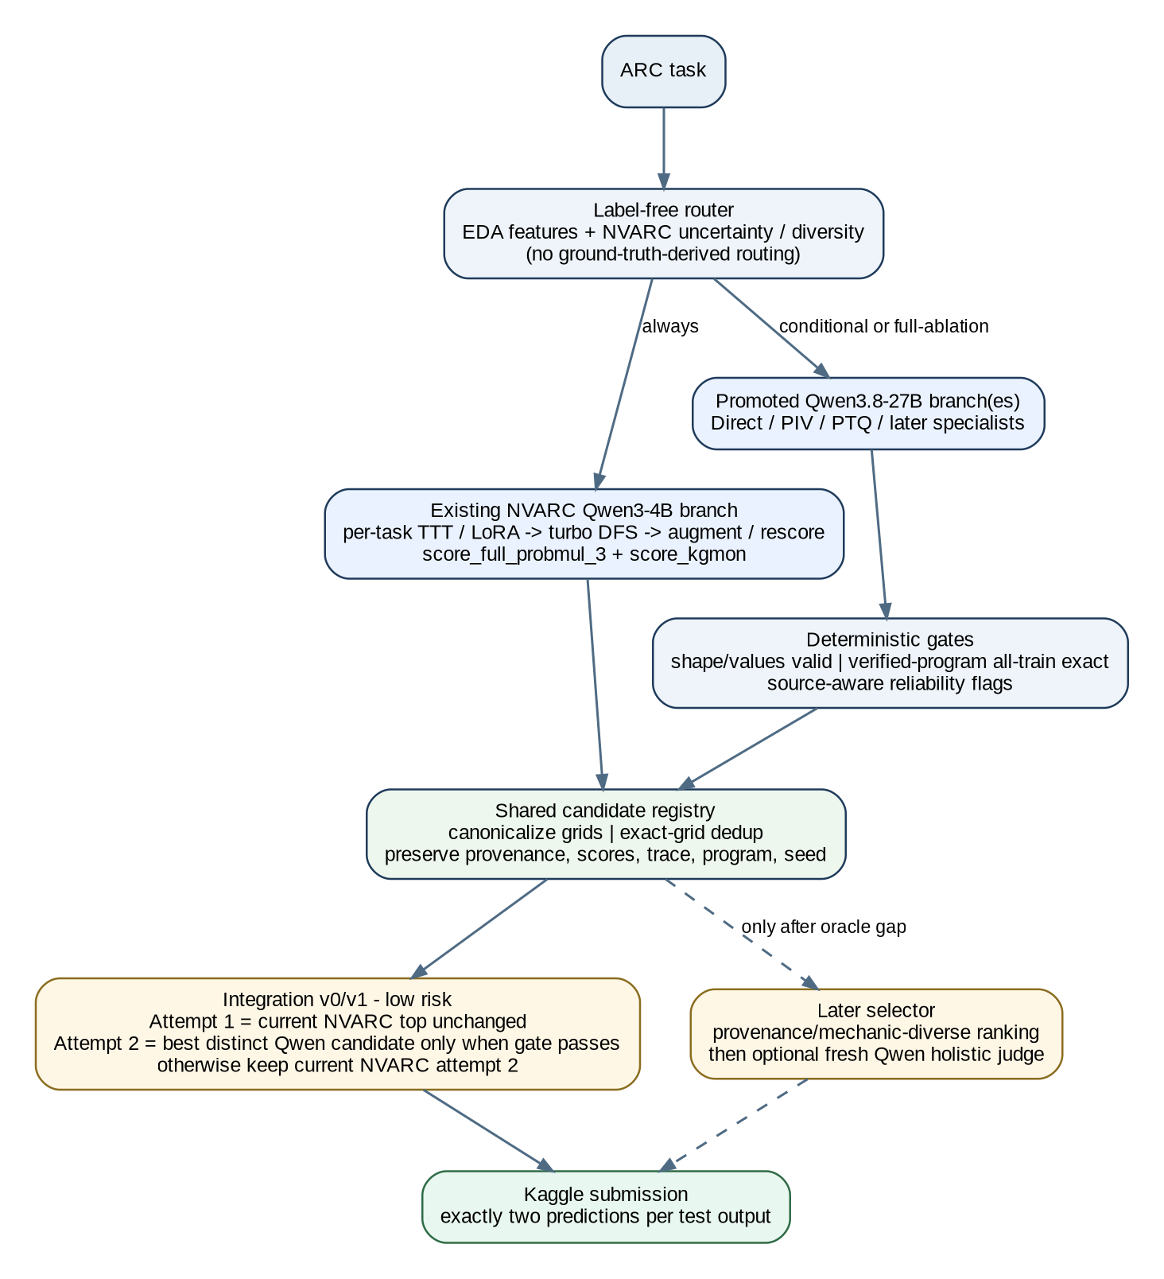

4.1 Why this architecture matches our notebook findings
- The 31-experiment diagnostic notebook found GT present in only 55/172 output candidate pools (32.0%) in that analysis, so candidate coverage is a primary bottleneck.
- The same diagnostic showed a current selected diagnostic score around 33.50 versus an oracle of 41.17 from the existing pool: there is selection headroom, but not enough to justify solving selection before generation.
- Average raw-candidate duplication was about 37.8%, with some tasks much higher, indicating search budget collapse.
- The two NVARC scorers were highly correlated (about 0.961 rank correlation in that experiment), so a genuinely different Qwen generator is more valuable than another near-identical ranker.
- Therefore Qwen should first be evaluated by unique NVARC-union additions, not by whether it beats NVARC standalone.

4.2 Preserve the current NVARC branch
- Keep the existing Qwen3-4B ARC-specialized path: task-time adaptation/LoRA, turbo DFS generation, augmentation scoring and current candidate decoding.
- Preserve score_full_probmul_3 and score_kgmon outputs as source features even if final selection later changes.
- Do not alter the current 32.64-LB reported baseline notebook during B0 union analysis. Generate Qwen outputs separately first.
- The existing run_dual_selection behavior should not be the final hybrid selector; the hybrid system must explicitly distinguish NVARC rank-2 from a genuinely different Qwen hypothesis.

4.3 Integration stages - one by one
Stage | Notebook change | Attempt 1 | Attempt 2 | Promotion condition
B0 - Offline union only | No submission change. Import saved Qwen candidates into an analysis cell. | Current NVARC | Current NVARC | Qwen adds unique oracle/GT coverage on frozen eval outputs.
B1 - Safe hybrid slot 2 | Add Qwen candidate registry + gate. | Current NVARC top unchanged | Best distinct gated Qwen candidate; fallback=current NVARC attempt 2 | No regression on stable NVARC cases; measurable unique recovery.
B2 - Conditional Qwen router | Run Qwen only on label-free hard/uncertain tasks. | Current NVARC top | Hybrid distinct candidate | Projected 12h runtime becomes feasible without losing B1 gains.
B3 - Source-aware selector | Rank union candidates by provenance + reliability + NVARC scores. | Best source-aware candidate | Best mechanic-diverse nonduplicate | Improves selected score while preserving oracle coverage.
B4 - Holistic judge | Add JUD-Q27-J0 only on ambiguous tasks. | Judge choice 1 | Judge choice 2 | Closes a material oracle-selected gap with acceptable compute.

4.4 Label-free routing features for hidden/private inference
- Task structure: dynamic output shape, multi-query count, input/output size ratio inferred from training pairs, grid size, color count/rarity, separators/subgrids and object count.
- NVARC search signals: number of unique decoded grids, duplicate ratio, score margin between top candidates, disagreement between score_full_probmul_3 and score_kgmon, beam/search exhaustion, invalid-grid rate.
- Qwen program signals: whether a verified all-train program was found, number of independent train-perfect mechanics, program/runtime stability.
- Do not route using public-eval ground-truth similarity or "near miss to GT" because those labels do not exist in the competition test rerun.

4.5 Low-risk first hybrid selector
Recommended B1 rule: Keep NVARC attempt_1 exactly unchanged. Replace attempt_2 only when Qwen supplies a valid, distinct candidate that passes the branch-specific gate (for programs: exact all-train verification). Otherwise retain the current NVARC attempt_2. This isolates complementarity with minimal leaderboard risk.

4.6 Candidate pool merge contract
- Canonicalize every grid to an immutable tuple-of-tuples representation and validate values 0-9 / rectangular shape.
- Deduplicate exact grids, but merge provenance arrays rather than discarding duplicate sources.
- Keep NVARC scores, Qwen source, seed, program verification, trace summary and runtime in the same record.
- For multi-query tasks, select two outputs independently per test output while retaining task-level provenance for analysis.
- Write merged-candidate JSON immediately so later selector experiments can be rerun without repeating Qwen inference.

5. Practical One-by-One Workflow
Order | Action | Decision
Step 1 | Run Q0 load/warmup. | If unstable: stop and fix runtime. If stable: freeze engine config.
Step 2 | Run Q1 Direct OFF/XHIGH and freeze parser/interface. | Save every candidate and compute NVARC offline union; do not integrate yet.
Step 3 | Run Q2 PIV on Proxy-48. | If no verified unique gain: do not scale it globally.
Step 4 | Run Q3 PTQ on the same Proxy-48 with matched budget. | Choose PIV, PTQ or small union at Q4.
Step 5 | Run B0 offline NVARC union using saved outputs. | If Qwen adds no unique coverage, stop architecture expansion and revisit prompts/model capability.
Step 6 | If code branch adds value, run Q5 LANG. | Keep only if it adds a new failure-recovery family.
Step 7 | Run Q6 CORE or Q7 LIB only when their trigger segment exists. | These are routed specialists, never default global branches initially.
Step 8 | Run B1 low-risk hybrid attempt_2. | Attempt_1 remains the 32.64-LB NVARC behavior.
Step 9 | If runtime is too high, add B2 conditional routing. | Use label-free EDA/NVARC uncertainty signals.
Step 10 | Only if oracle-selected gap is now meaningful, run Q8/B4 judge. | Selection comes after generation coverage.
Step 11 | Only after the core pipeline is stable, test one late mechanism at a time. | Athanor review -> Squeeze routing -> Imbue evolution -> ARCgentica delegation, only if a specific bottleneck justifies it.
Do not do this: Do not build a single notebook containing PIV + PTQ + LANG + CORE + LIB + evolution + multi-agent delegation + judge before any one of them is measured. That makes failures impossible to attribute and will likely exceed the 4xL4 wall-clock budget.

5.1 Notebook/versioning discipline
- Create one notebook version per promoted experiment family, with the previous version kept runnable.
- Every run writes a manifest containing git/notebook hash, model path, vLLM config, task IDs, seeds, token caps and wall-clock budget.
- Separate generation artifacts from selector artifacts. A new selector should be able to re-score saved candidate pools without re-running the model.
- Never silently change the evaluation denominator. Store output-weighted pass@2, task-normalized and oracle coverage side by side.

5.2 Suggested file/module boundary
q27_runtime.py # vLLM/TP4 load, sampling profiles
q27_format.py # serialization + tolerant grid parser
q27_direct.py # OFF/XHIGH generator
q27_tools.py # subprocess sandbox + deterministic verifier
q27_piv.py # stateful REPL agent
q27_ptq.py # fresh-call refinement
q27_specialists.py # LANG / CORE / LIB (conditional)
candidate_store.py # canonical grids + provenance + checkpoints
metrics.py # Kaggle + task-normalized + oracle/union metrics
nvarc_bridge.py # import NVARC candidate pools and scores
hybrid_selector.py # B1/B3 selector; judge disabled by default
q27_judge.py # late JUD-Q27-J0 only

6. Primary Source Map
- Qwen3.8-27B-FP8 official model
- NVARC
- Confluence Labs ARC-AGI-2
- Squeeze-Evolve
- Athanor
- Imbue Darwinian Evolver
- Noemon
- Symbolica ARCgentica
- PiVOTools Agentic Coding article
- PiVOTools ARC repo
- Poetiq ARC solver
- Johan Land - Modality-Driven Search
- CoreThink
- Jeremy Berman - evolutionary NL instructions
- Eric Pang - evolutionary program synthesis
- Verified ARC-AGI-2 public-training programs
- ARC Prize Community Leaderboard
- Kaggle ARC Prize 2026 competition

7. Promotion Checklist for Every Experiment
- ☐ Same frozen task subset and same evaluation denominator as the comparison run.
- ☐ Candidate files, provenance and traces saved before selection.
- ☐ Official output-weighted pass@2 + task-normalized + oracle/union metrics recorded.
- ☐ Unique NVARC additions listed by task/test-output ID.
- ☐ EDA breakdown recorded, especially multi-query, dynamic, large/high-ratio and hard tiers.
- ☐ Tokens, tool calls and wall-clock projected to the full Kaggle rerun.
- ☐ At least one rerun/seed check before promoting a stochastic method.
- ☐ If no unique coverage or efficiency benefit: remove the branch rather than keeping it "just in case".
- ☐ Only after a branch is promoted may it enter the NVARC hybrid notebook.
Final target: A small, auditable hybrid: NVARC remains the ARC-specialized 4B generator; Qwen3.8-27B contributes only the branches that prove complementary coverage under 4xL4; the selector uses two attempts efficiently; every additional mechanism has a measured reason to exist.

